16.
from sklearn.datasets import load_iris
from sklearn.tree import DecisionTreeClassifier
from sklearn.neighbors import KNeighborsClassifier
X,y=load_iris(return_X_y=True)
print("DT:",DecisionTreeClassifier().fit(X,y).score(X,y))
print("KNN:",KNeighborsClassifier().fit(X,y).score(X,y))
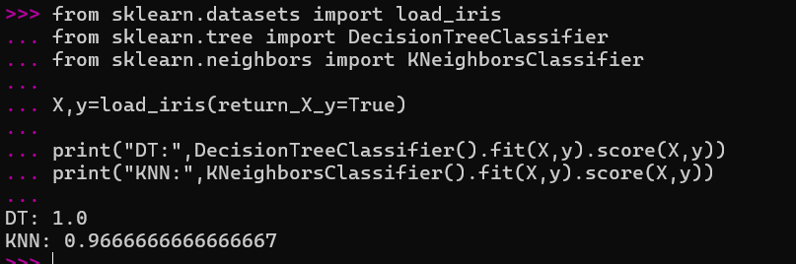

17.
from sklearn.linear_model import LinearRegression
X=[[4],[6],[8],[10]]
y=[10000,15000,20000,25000]
m=LinearRegression()
m.fit(X,y)
print(m.predict([[12]]))
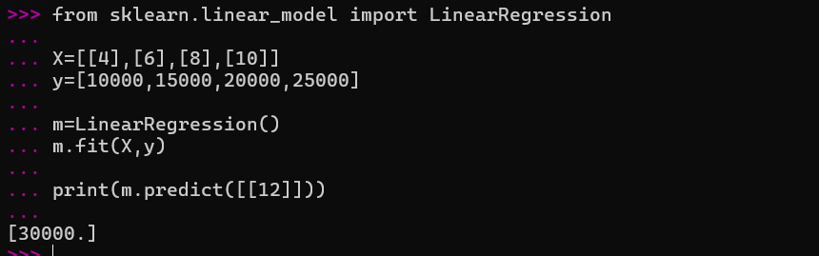

18.
from sklearn.datasets import load_iris
from sklearn.linear_model import Perceptron
X,y=load_iris(return_X_y=True)
m=Perceptron()
m.fit(X,y)
print(m.predict([X[0]]))
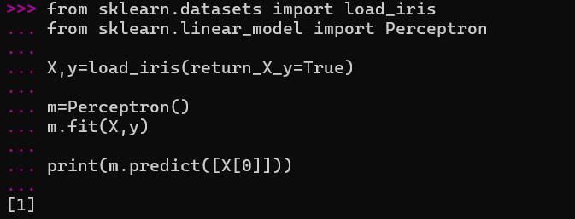

19.
from sklearn.naive_bayes import GaussianNB
X=[[25],[35],[45],[55]]
y=['No','No','Yes','Yes']
m=GaussianNB()
m.fit(X,y)
print(m.predict([[50]]))
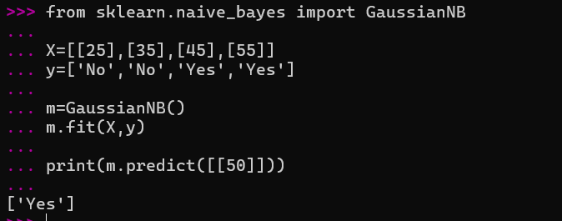
20.
from sklearn.linear_model import LinearRegression
X=[[1],[2],[3],[4]]
y=[100,200,300,400]
m=LinearRegression()
m.fit(X,y)
print(m.predict([[5]]))
